In the Bubble Track Experiment, I attempted to compare the kinetic energy and the momentum of an electron traveling through liquid hydrogen in a magnetic field. I took measurements of the electron’s total distance to the center of the spiral and instantaneous radius using a roller (?) and a ruler, finding tangent lines to points about a centimeter(?) away from the point selected for measuring. I found that the relationship between the kinetic energy and the momentum of an electron traveling through liquid hydrogen in a magnetic field is much better described by Einstein’s theory of special relativity rather than the classical relationship between kinetic energy and momentum.

Kinetic Energy and Momentum of the Electron in the Bubble Track Experiment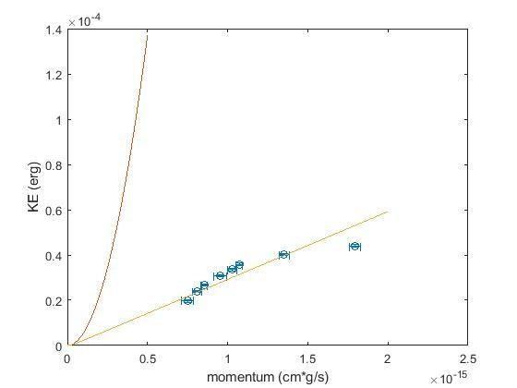

Figure 1: Theory curves for both classical (red) and relativistic (yellow) predictions of the electron’s kinetic energy based on its momentum plotted with measured data points and their uncertainties (blue).

$$p=mu$$

$$E_{k}=\frac{1}{2}mu^{2}$$

$$E_{k}=\frac{p^{2}}{2m}$$

$$E_{k}={(mc^{2})}^{2}+{(pc)}^{2}-mc^{2}$$

In Figure 1, the red line is what the classical equations:

*p=mu* , *E =1/2mu2* , *E=(p2)/2m* predict for the kinetic energy of the electron based on its momentum.

Similarly, the yellow line is what the relativistic equation: *E= ((mc2)2+(pc)2) -mc2* predicts for the kinetic energy of the electron based on its momentum.

As shown in Figure 1, the relativistic theory curve is a much better model for the data I have taken.

But, the model does not fit the data I have taken exactly. To calculate the standard errors of the data I calculated the standard deviation for each of the 8 points I took data from for both the radius and distance measurements. This involved taking the three measured values for each point, summing them, and then dividing the sum by the square root of the number of measurements, namely three. I then added to that quotient 0.1 for the radius measurements and 1.0 for the distance measurements. I added the extra uncertainty due to the measuring devices I used (a roller and a ruler, with smallest measurement divisions of 1 cm and 0.1 cm, respectively).

The following is a table showing the calculated uncertainties for both radius and distance for all points:

|  |  |  |  |  |
| --- | --- | --- | --- | --- |
| Point | Average Measured Radius | Uncertainty in Radius | Average Measured Distance | Uncertainty in Distance |
| 8 | 5.1 | 0.245 | 67 | 2 |
| 7 | 5.5 | 0.2 | 82 | 1.882 |
| 6 | 5.8 | 0.133 | 92 | 1.577 |
| 5 | 6.5 | 0.276 | 106 | 1.333 |
| 4 | 7 | 0.2 | 116 | 2 |
| 3 | 7.3 | 0.133 | 124 | 2.202 |
| 2 | 9.2 | 0.215 | 140 | 1.333 |
| 1 | 12.2 | 0.245 | 153 | 1.882 |

Table 2: A Table showing the average measured radius, uncertainty in the average measured radius, the average measured distance, and the uncertainty in the average measured distance for each point.

These results show that the classical equation linking kinetic energy and momentum only holds for low momentum, low energy objects. It does a poor job of modeling how much kinetic energy the electron had based on its momentum. Additionally, these results show that the relativistic equation linking kinetic energy and momentum is very accurate for high energy, high momentum objects.

Most all of the measured points fall on the relativistic theory curve within their accepted error, except for one clear outlier. That outlier is point 8, the first point chronologically in the electron’s path. This point is the one with the most momentum and energy, which means it had the largest radius and the furthest distance traveled, which makes it easier to introduce measurement and human errors. I believe that the reason for the outlier is human error, specifically a mis-measurement.